Direct manipulation

The term “direct manipulation” was coined by Ben Shneiderman.

Direct manipulation is an interactive technique which represents tasks in the form of objects and actions in a way that makes users feel that they are performing the tasks themselves directly, and not through some intermediary (computer).

Direct manipulation is characterized by:
- visibility of the object(s) of interest
- incremental action at the user interface with rapid feedback on all actions
- reversibility of all actions, so that users are encouraged to explore without severe penalties
- syntactic correctness of all actions, so that every user action is a legal operation
- replacement of complex command languages with actions to manipulate directly the visible objects

One of the consequences of the direct manipulation paradigm is that there is no longer a clear distinction between input and output – output expressions are used to formulate subsequent input expressions.
[For instance, the document icon is an output expression in the desktop metaphor, but that icon is used by the user to articulate the move operation.]

Another example:
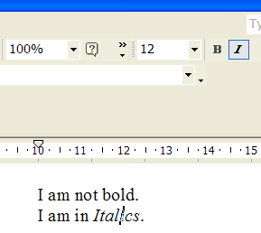
Note that in the above example, the visible objects for Bold and Italics are serving as output expressions regarding the text, but they can also be used to provide input (to make the text bold or have it in Italics)

